
Areesha Raheel
55039
BSIT-6
Problem Solving-III
Lab Report 1:
Computational Complexity and Algorithm Analysis

Objective
The purpose of this lab is to understand deterministic algorithms and their polynomial-time solutions, and to perform dry runs for a deterministic problem such as Binary Search.

Introduction
Deterministic problems are problems that can be solved using a deterministic Turing machine in polynomial time (O(n^k)). These problems belong to the P Class in computational complexity theory. A classic example of a deterministic problem is Binary Search, which efficiently finds an element in a sorted array.

Problem Statement
Given a sorted array of integers, find whether a target element exists in the array using Binary Search.
Example:
Sorted array = [2, 5, 8, 12, 16]
Target = 12

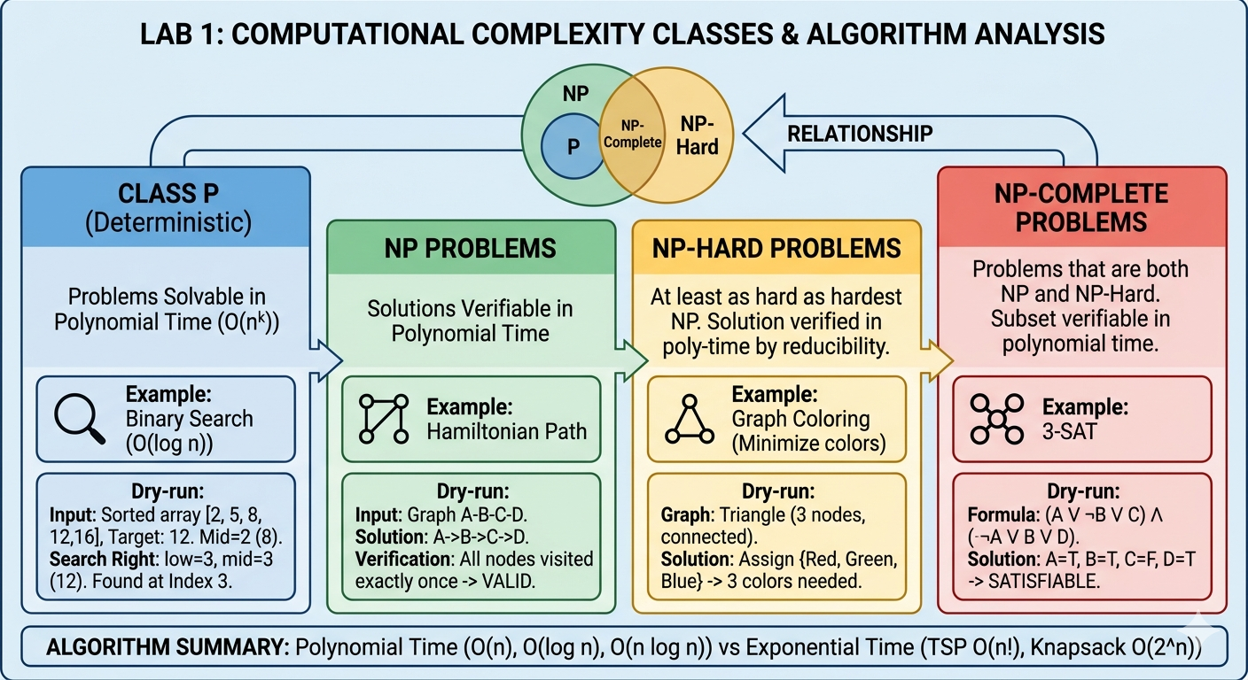

Algorithm: Binary Search
Step 1: Initialize low = 0 and high = n-1 (where n is the size of the array).
Step 2: While low <= high
a. Compute mid = (low + high) / 2
b. If array[mid] == target, return mid (element found)
c. Else if array[mid] < target, set low = mid + 1
d. Else, set high = mid - 1
Step 3: If element not found, return -1

Flowchart / Diagram
Binary Search Diagram:

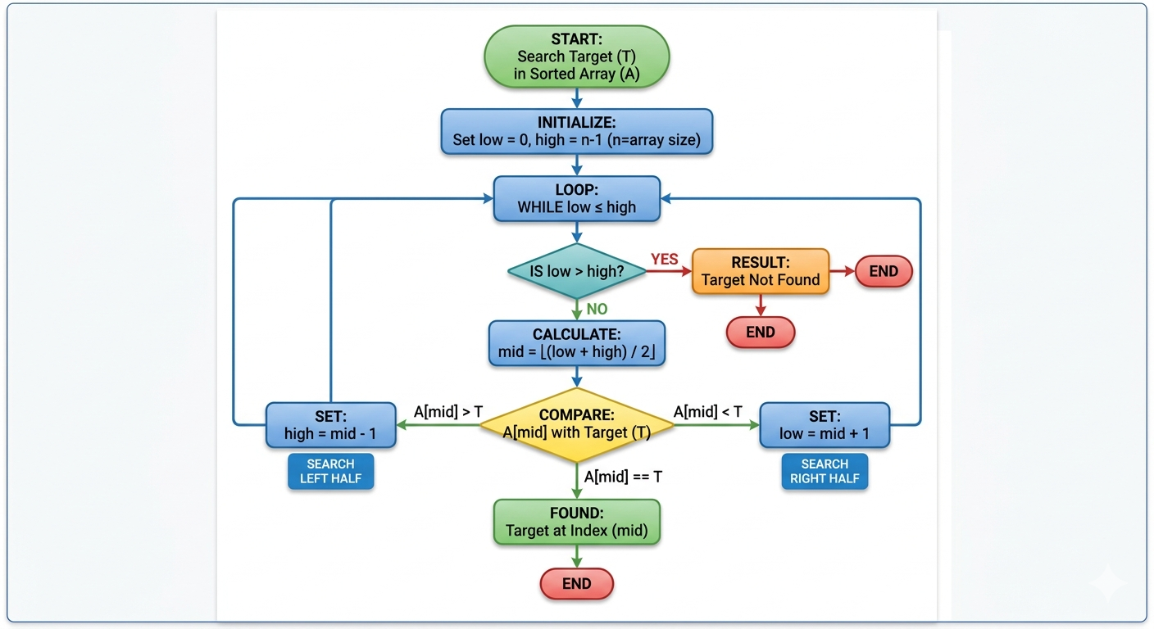

Dry Run Table
Step | Low | High | Mid | array[mid] | Target | Action
1 | 0 | 4 | 2 | 8 | 12 | 8 < 12 → low = mid + 1 = 3
2 | 3 | 4 | 3 | 12 | 12 | 12 = 12 → Element Found
Result: Element 12 found at index 3.

Code Implementation
def binary_search(arr, target):
low = 0
high = len(arr) - 1
while low <= high:
mid = (low + high) // 2
if arr[mid] == target:
return mid
elif arr[mid] < target:
low = mid + 1
else:
high = mid - 1
return -1
# Test
arr = [2, 5, 8, 12, 16]
target = 12
result = binary_search(arr, target)
if result != -1:
print(f"Element found at index {result}")
else:
print("Element not found")
Output:
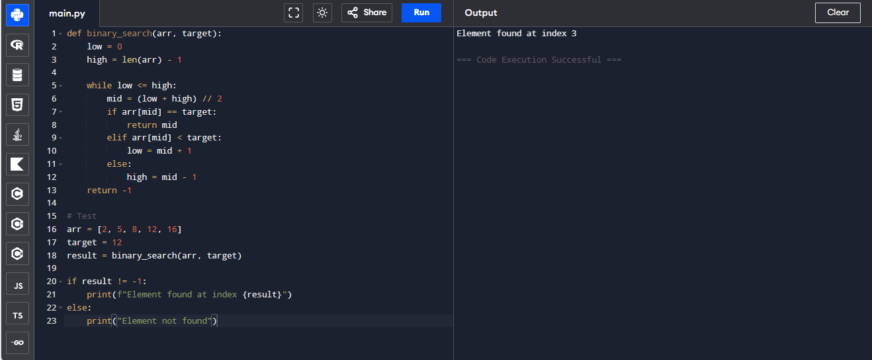
Element found at index 3

Time Complexity Analysis
- Best Case: O(1) – Element found at the middle of the array immediately.
- Worst Case: O(log n) – Binary search divides the array until one element remains.
- Average Case: O(log n)

Conclusion
- Binary Search is a deterministic algorithm and solves the search problem in polynomial time.
- Deterministic problems in P class are efficiently solvable, unlike NP-Hard problems.
- Dry run confirms that Binary Search works correctly and efficiently.

